Course: IS 312 – Web Design and Programming

Quarter: Fall - 2022

Your Name: Christian Morris

Task 1:

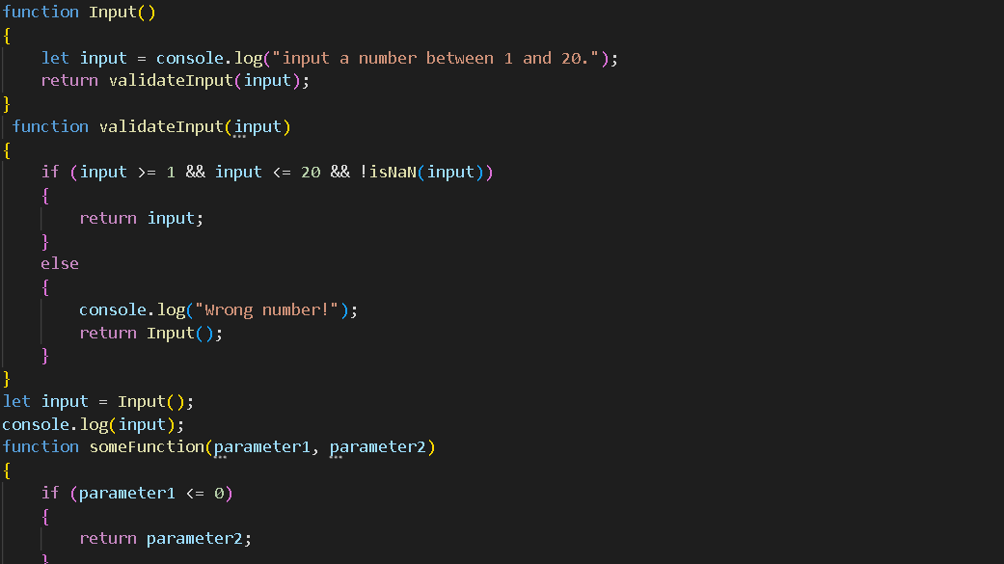

Task 2:

Task 3:

Task 4:

The two main things I think I took from this assignment would be learning about Fibonacci sequence and learning about parsing. The Fibonacci Sequence starts with 0 and 1 but will constantly add onto itself with the most recent number. Parsing is the method of converting types. For example if you need to convert from type Int to String.